- TITLE PAGE

PROJECT REPORT
(Project Term August-November 2021)

(MUSIC RECOMMENDATION SYSTEM)

Submitted by

(PIYUSH VYAS ) Registration Number :…11909779……….

Project Group Number …A32……….

Course Code ……INT246………………

Under the Guidance of

(MR. SAGAR PANDE SIR)

School of Computer Science and Engineering



DECLARATION
We hereby declare that the project work entitled (“Music Recommender System”) is an authentic record of our own work carried out as requirements of Project for the award of B.Tech degree in School of Computer Science and Engineering from Lovely Professional University, Phagwara, under the guidance of Mr. Sagar Pande Sir, during August to November 2021. All the information furnished in this project report is based on our own intensive work and is genuine.

Project Group Number: …A32………

Name of Student : ……Piyush Vyas…………………………
Registration Number: …11909779………………………..

piyushv
(Signature of Student)
Date: 21/11/2021

Certificate

This is to certify that the declaration statement made by this group of students is correct to the best of my knowledge and belief. They have completed this Project under my guidance and supervision. The present work is the result of their original investigation, effort and study. No part of the work has ever been submitted for any other degree at any University. The Project is fit for the submission and partial fulfillment of the conditions for the award of B.Tech degree in School of Computer science and Engineering from Lovely Professional University, Phagwara.

Signature and Name of the Mentor

Designation

School of Computer Science and Engineering,
Lovely Professional University,
Phagwara, Punjab.

Date : 21/11/2021

ACKNOWLEDGEMENT

The success and final outcome of learning, Machine Learning (soft computing) required a lot of guidance and assistance from many people and I am extremely privileged to have got this all along the completion of my course and few of the projects. All that I have done is only due to such supervision and assistance and I would not forget to thank them.
I respect and thank Mr. Sagar Pande Sir , for providing me an opportunity to do the course and project work and giving me all support and guidance, which made me complete the course duly. I am thankful to and fortunate enough to get constant encouragement, support and guidance from the faculty of Lovely Professional University, which helped us in successfully completing my course and project work.

Date :- 21/11/2021 Signature :- piyushdv
Name :- Piyush Vyas
Reg. no. :- 11909779

Table of Contents

1. Introduction…………………………………………………………………………6.
2. Profile of the Problem. Rationale/Scope of the study (Problem Statement)…….7.
3. Theory section……………………………………………………………………….8.
4. Recommender System……………………………………………………………....11.
5. Matter in Recommender System…………………………………………………...17.
6. Libraries and Tools…………………………………………………………………18.
7. Methodology…………………………………………………………………………19.
8. Defining AI…………………………………………………………………………..21.
9. Limitations and Enhancement……………………………………………………..28.
10. Conclusion………………………………………………………………………….29.
11. Bibliography………………………………………………………………………..30.
12. Snapshots…………………………………………………………………………...31.

INTRODUCTION

On the Internet, where the number of choices is overwhelming, there is need to filter, prioritize and efficiently deliver relevant information in order to alleviate the problem of information overload, which has created a potential problem to many Internet users. Recommender systems solve this problem by searching through large volume of dynamically generated information to provide users with personalized content and services.

Besides, these days social networks have become widely used and popular mediums for information dissemination as well as the facilitators of social interactions. User contribution and activities provide a valuable insight into individual behavior, experiences, opinions and interests.Considering that personality, which uniquely identifies each one of us, affects a lot of aspects of human behavior, mental process and affective reactions, there is an enormous opportunities, for adding new personality based qualities in order to enhance the current collaborative filtering recommendation engine.

1.1 Objectives

The objectives of the project can be summarized with the points below:

1. To find out if the personality of the user can be a crucial factor in the music recommendation system.

2. To find out if collaborative recommendation engine can be enhanced via the use of personality for similar user computation.

1.2. Scope of the Project
The most important scope of the project will be to discover if the personality traits of an individual can be used for the enhancement of the recommendation engine in order to provide the more personalized content to the user as a recommendation.

- Problem Statement

Music is an essential part of human life. Music is the pleasant sound that leads us to experience harmony and higher happiness. With the advancement in technology, music has significantly progressed and increased in terms of quality and volume. The type of music people create and listen differs according to place and culture. The taste of music even differs from person to person and even in moods of same person. So, it is very useful if we could determine some method to find what kind of music a person might be interested in listening and use this finding to recommend music to him/her.

Collaborative filtering is one the most popular filtering techniques today and with this project we aim to enhance it.For this, 4 we have assumed that the personality of the user might be one of the key factor in his/her music listening habit. Hence, via this project, we are to see if the personality of the user might have any impact on the collaborative filtering enhancement assuming the correlation between the personality and music listening habit exists.

2.1. Understanding Of Requirement
Nowadays, digital data on the Internet has been massive than ever, which have created a potential challenge of information overload, hindering timely access of items of interest on the Internet. So, there is a requirement for the better recommendation system than ever. Thus with this project, we will try to find out if the recommendation engine can perform better if personality of the individual is used as one of the metrics for a recommendation.
Nowadays, social networking sites have become vastly popular among several people of different religion, caste, ethnic groups and different location of the world, which shows how culturally diverse the people around the world is. And in this diversity, we can also see the varieties in the personalities of people living in different parts of the world. The main purpose of the social networking sites are to connect different peoples from different parts of the world which makes it the most suitable platform in order to study the personality traits of the user. Thus studied personality traits might be used in recommendation engine in order to improve it’s efficiency.

3. THEORETICAL BACKGROUND

3.1. General

The project tries to study the impact of the personality on the collaborative recommendation engine. Thus, initially personality of the user has to be predicted which can be done via the user’s study on social media i.e Facebook where a status update might be one of the good metric to predict the personality using ”document classification” technique and the traits of the person are used as the similarity metric for similar user computation on ”collaborative filtering”.

3.2. Document Classification

Document Classification is an example of Machine Learning(ML) in the form ofNatural Language Processing(NLP). By classifying text, we are aiming to assign one or more classes or categories to a document, making it easier to manage or sort. Broadly speaking, there are two classes of ML techniques:

Unsupervised:

In unsupervised method, model is responsible for clustering of a similar document.

Supervised:

In supervised methods, a model is created based on training set. Categories are predefined and documents within the training dataset are manually tagged with one or more category labels. A classifier is then trained on the dataset which means it can predict a new document’s category from then on. ”This is the technique that has been used in the project.”

3.3. Obtaining a dataset
The quality of the tagged dataset is by far the most important component of a statistical NLP classifier. The dataset needs to be large enough to have an adequate number of document in each class. The datasets also needs to be of a high enough quality in terms of how distinct 8 the documents in the different categories are from each other to allow a clear delineation between categories .

3.4. Preprocessing
Preprocessing or Data preprocessing is a data mining technique that involves transforming raw data into an understandable format(as per requirement of the project may differ from the need of the project). It comprises of various steps:
• Data Cleaning: Data is cleansed through processes such as filling in missing values, smoothing the noisy data or resolving the inconsistencies in the data.
• Data Integration: Data with different representation are put together and conflicts within the data are resolved.
• Data Transformation: Data is normalized, aggregated and generalized.

4. Recommender System

Recommender systems were originally defined as ”people provide recommendations as inputs, which the system then aggregates and directs to appropriate recipients”, like using experts knowledge as input for the system to enrich it’s ability to recommend to people according to the given knowledge. However, now the term has a broader connotation,describing any system that produces individualized recommendations as output or has the effect of guiding the user in a personalized way to interesting or useful objects in a large space of possible options.
Recommender systems are information filtering systems that deal with the problem of information overload by filtering vital information fragment out of large amount of dynamically generated information according to user’s preferences, interest, or observed behavior about item. Recommender system has the ability to predict whether a particular user would prefer an item or not based on the user’s profile.
Recommender system are beneficial to both service providers and users.Recommendation systems have also proved to improve decision making process and quality. In e-commerce setting, recommender system aids to enhance revenues, for the fact that they are effective means of selling more products. In scientific libraries, recommender system supports users by allowing them to move beyond catalog searches. Therefore, the need to use efficient and accurate recommendation techniques within a system that will provide relevant and dependable recommendations for users cannot be over-emphasized.
Recommender system typically produce a list of recommendation in one of two ways- through collaborative and content filtering. Collaborative filtering approaches build a model from a user’s past behavior(items previously purchased or selected and numerical rating given to those items) as well as similar decisions made by other users. This model is then used to predict items(or ratings for items) that the user may have an interest in. Content-based fil- tering approaches utilize a series of discrete characteristics of an item i.e item-profile based on the purchase history of the user i.e with the help of user-profile in order to recommend items. The Hybrid recommender system is the one in which the one or more recommender system is combined for the recommendation.
Besides there are several categorization of recommendation system which is enlisted below:
1. Personalized Recommendation: It involves online suggestion of data in any format that is relevant to each and every user, based on the user’s implicit behavior and provided details.
(a) Knowledge Based Recommendation(Searching)
(b) Content Based Recommendation
(c) Collaborative Recommendation
i. Memory Based(user based, item based)
ii. Model Based(clustering techniques, association techniques, Bayesian networks, neural networks, latent factor)
(d) Hybrid Recommendation
2. Non-Personalized Recommendation: It is a recommendation system that recommends items to consumers based on what other consumer have said about the product in an average i.e the recommendations are independent of the customer, so all customers gets the same recommendation.

4.1. Knowledge based Recommendation(Searching)

Knowledge based recommendation system [22] is based on the explicit knowledge about item classification, user interest and recommendation standard(which item should be recommend in which feature). It is an alternative approach to the collaborative filtering.

4.1.1 Working Mechanism

1. Recommendation: Here recommendation is made based on explicit knowledge.

4.1.2 Pros

• Free from cold-start problem.

• Sensitive to changes of preference.

• Can include non-product features.

• Can map from user needs to products.

4.1.3 Cons

• Suggestion ability is static(no learning model)

4.2. Content based Filtering

Content based technique is a domain-dependent algorithm and it emphasizes more on the analysis of the attributes of items in order to generate predictions. When documents such as web pages, publications and news are to be recommended, content-based filtering technique is the most successful. In content-based filtering technique, recommendation is made on the user profiles using features extracted from the content of items the user has evaluated in the past.

4.2.1. Working Mechanism

1. Item Profile Creation: Here initially, item profile is created in order with the help of it’s feature. In case of movie, music meta data available can be used for item profile creation.

2. User Profile Creation: User profile is created, based on their interaction with the item i.e with the help of the their rating on the items. Hence user profile is created with the help of the item profile either by taking the average of item-profile or weighted average of item-profile.

3. Recommendation: Cosine similarity is used for the similarity computation between the user profile and the profile of items to be recommended, items with the highest similarity are recommended to the user.

4.2.2. Pros

• Implicit feedback is sufficient.

• Adaptive quality improves over time.

4.2.3. Cons

• New user ramp-up problem(cold start problem).

• Quality dependent on large historical data set.

• Stability Vs Plasticity problem.

Content based filtering can outperform the collaborative, whenever the the ratio of item to user is very high.

4.3 Collaborative Filtering

Collaborative filtering ]is a domain-independent prediction technique used for content that cannot easily and adequately be described by meta data such as movies and music. Collaborative filtering technique works by building a database(user-item) matrix of preference for items by users. It then matches users with relevant interest and preferences by calculating similarities between their profiles to make recommendations. Such users build a group called neighborhood. An user get recommendation to those items that he has not rated before but were already positively rated by users in his neighborhood. Recommendation that are produced by CF can be either prediction or recommendation. Prediction is a numerical value expressing Ri j, expressing the predicted score of item ’j’ for the user ’i’, which recommendation is a list of top N items that the user will like the most as shown in the figure below. The technique of collaborative filtering can be divided into two categories: memory based and model based.

• Memory Based: This approach uses user rating data to compute the similarity between users or items. This is used for making recommendations. This was an early approach used in many commercial systems. It’s effective and easy to implement. Typical examples of this approaches are neighborhood-based CF and item-based/user-based top-N recommendations. The user based top-N recommendation algorithm uses a similarity based vector model to identify the k most similar users to an active user. After the k most similar users are found their corresponding user-item matrices are aggregated to identify the set of items to be recommended. The advantages with this approach include: the explainability of the results, which is an important aspect of recommendation system, easy creation and use, easy facilitation of new data, content-independence of the items being recommended, good scaling with co-rated items.There are several disadvantages with this approach. It’s performance decreases when data gets sparse, which occurs frequently with web-related items. This might hinder the scalability of this approach and creates problems with large datasets.

• Model Based: In this approach, models are developed using different data mining, machine learning algorithms to predict user’s rating of unrated items. There are many model-based CF algorithms. Bayesian networks, clustering models, latent semantic models such as singular value decomposition, probabilistic latent semantic analysis, multiple multiplicative factor etc.

4.3.1. Pros

• Can identify cross-genre items.

• Domain knowledge not needed

• Adaptive: quality improves over time.

• Implicit feedback sufficient.

4.3.2. Cons

• New user/item ramp-up problems(cold-start problem)

• Gray sheep problem

• Stability vs Plasticity problem

4.4. Hybrid Recommendation System

All of the known recommendation techniques have strengths and weakness and many researchers choose to combine the techniques in different ways. The different approaches used for the modeling of hybrid recommendation system are:

• Weighted: The scores of several recommendation techniques are combined together to produce a single recommendation.

• Switching: The system switches between recommendation techniques depending on the current situation.

• Mixed: Recommendation from several different recommender systems are presented at the same time.

• Feature Combination: Feature from different recommendation data sources are thrown together into a single recommendation algorithm.

• Cascade: On recommender refines the recommendation given by another.

• Feature augmentation: Output from one technique is used as an input feature to another.

• Meta-level: The model learned by one recommender is used as input to another.

5. Matters in recommendation system

1. Data Collection: The data used by recommendation engines can be categorized into explicit and implicit data. Explicit is all data the user themselves feed into the system. The collection of explicit data must not be intrusive or time consuming. Implicit data source in e-commerce is the transaction data. Implicit data needs to be analyzed before it can be used to describe user features or user-item ratings.

2. Cold Start/Ramp-Up: The cold start problem occurs when too little/no rating data is available in the initial state. The recommendation system then lack data to produce appropriate recommendations. They mostly occur in the learning models. Two cold start problems are new user problem and new item problem.

3. Stability Vs Plasticity: The converse of the cold start problem is the stability vs plasticity. When consumers have rated so many items their preferences in the established user profiles are difficult to change.

4. Sparsity: In most use cases for recommendation systems, due to the catalog sizes of ebusiness vendors, the count of rating already obtained is very small related to the count of ratings that need to be predicted. But collaborative filtering techniques focuses on an overlap in ratings and have difficulties when the space of rating is sparse(few user have rated the similar items). Sparsity in the user-item rating matrix degrades the quality of the recommendations.

5. Performance and Scalability: Performance and scalability are important issues for recommendation systems as e-commerce websites must be able to determine recommendations in real-time and often deal with huge data sets of millions of users and items. The big growth rates of e-business are making the sets even larger in the user dimension.

6. Privacy: Privacy is an important issue in recommendation systems. To provide personalized recommendations, recommendation systems must know something regarding to users. In fact, the more the system know, the more precise the recommendation can get. Users are concerned about what information is gathered, how it is used, and if it is stored. These privacy affect both the collection of explicit and implicit data. Regarding explicit data, users are not interested to disclose information about themselves and their interests. If questionnaires get too personal, user may give false information in order to protect their privacy.
6. Libraries and Tools

6.1. Python

Python is a widely used high-level programming language for general-purpose programming. Python features a dynamic type system and automatic memory management and supports multiple programming paradigms, including object-oriented, imperative, functional programming, and procedural styles. It has a large and comprehensive standard library.

6.2. NumPy

NumPy is a library for the Python programming language, adding support for large, multidimensional arrays and matrices, along with a large collection of high-level mathematical functions to operate on these arrays.

6.3. Pandas

Pandas is a software library written for the Python programming language for data manipulation and analysis. In particular, it offers data structures and operations for manipulating numerical tables and time series. It offers wide range of features including DataFrame object for data manipulation with integrated indexing, tools for reading and writing data between in-memory data structures and different file formats, data alignment and integrated handling of missing data and more.

7. METHODOLOGY

7.1. Requirement Specification

A software requirement specification is a description of a software system to be developed. It lays out functional and non-functional requirements. It describes what the software product is expected to do and what not to do. It enlists enough and necessary requirements that are required for the project development. It mainly aids to describe the scope of the work and provide a software designers a form of reference.

7.1.1. Functional Requirement

The functional requirement specification of the project are mainly categorized as user requirements, security requirements, and device requirement each of which are explained in detail below:

• User Requirement: User should have account on Facebook and user must have at least one post needed to analyze the personality for the music recommendation.

• Security Requirement: The user can’t have access to the Facebook API. User must provide their own login credentials.

• Device Requirement: System must be initiated on web-browser.

7.1.2. Non-functional Requirement

The non-functional requirement of the system can be summarized as follows:

• Performance: The system shall have a quick, accurate and reliable results.

• Capacity and Scalability: The system shall be able to store personality computed by the system into the database.

• Availability: The system shall be available to user anytime whenever there is an Internet connection.

• Recovery: In case of malfunctioning or unavailability of server, the system should be able to recover and prevent any data loss or redundancy.

• Flexibility and Portability: System shall be accessible anytime from any locations.

7.2. Feasibility Assessment

Feasibility Assessment is done to analyze the viability of an idea. In case of software development, it performs the practicality of the project or system. The result from feasibility assessment determines whether the project should go ahead, be redesigned, or dropped. There are five areas of feasibility - Technical, Economic, Legal, Operational and Scheduling.

8. Definition of Artificial Intelligence

8.1 Data Economy

World is witnessing real time flow of all types structured and unstructured data from social media, communication, transportation, sensors, and devices.

International Data Corporation (IDC) forecasts that 180 zetta bytes of data will be generated by2025.

This explosion of data has given rise to a new economy known as the Data Economy.

Data is the new oil that is precious but useful only when cleaned and processed.

There is a constant battle for ownership of data between enterprises to derive benefits from it.

8.2 Define Artificial Intelligence

Artificial intelligence refers to the simulation of human intelligence in machines that are programmed to think like humans and mimic their actions.

The term may also be applied to any machine that exhibits traits associated with a human mind such as learning and problem- solving.

8.3 Definition of Machine Learning

Relationship between AI and ML

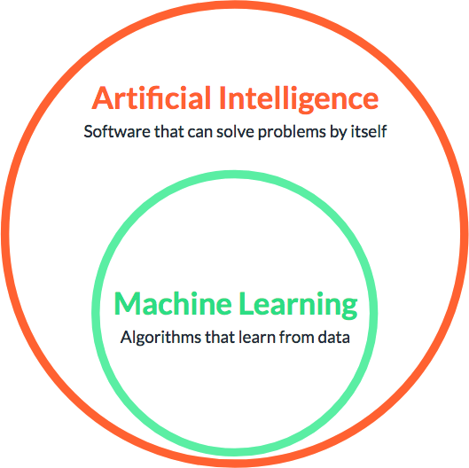

Machine Learning is an approach or subset of Artificial Intelligence that is based on the idea that machines can be given access to data along with the ability to learn from it.

Features of Machine Learning

Machine Learning is computing-intensive and generally requires a large amountof training data.

It involves repetitive training to improve the learning and decision making of algorithms.

As more data gets added, Machine Learning training can be automated forlearning new data patterns and adapting its algorithm

8.3 Machine Learning Algorithms

8.3.1 Traditional Programming vs. Machine Learning Approach

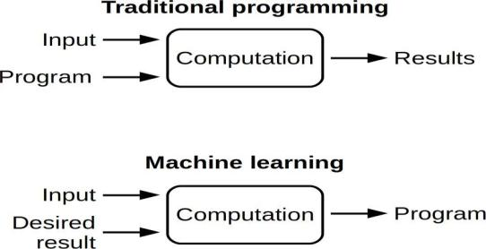

8.3.2 Traditional Approach

Traditional programming relies on hard-coded rules

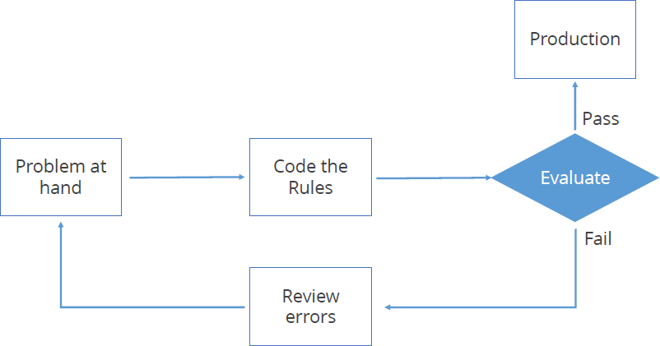
.

8.3.3 Machine Learning Techniques

Machine Learning uses a number of theories and techniques from Data Science.
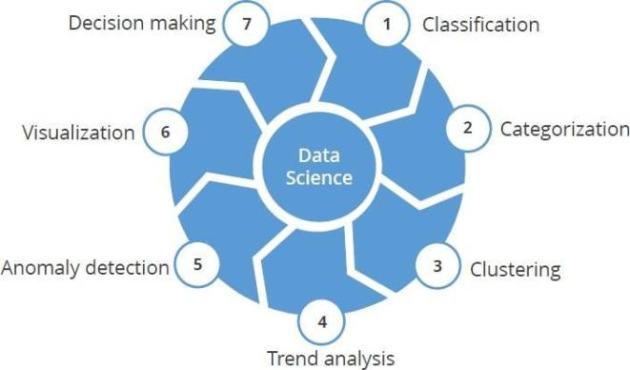

Machine Learning can learn from labelled data (known as supervised learning) or unlabeled data (known as unsupervised learning).

8.4. Applications of Machine Learning

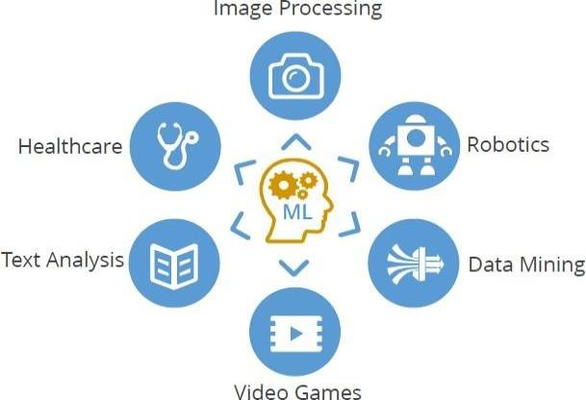

Image Processing

Optical Character Recognition (OCR)

Self-driving cars

Image tagging and recognition

Robotics

Industrial robotics

Human simulation

Data Mining

Association rules

Anomaly detection

Grouping and Predictions

Video games

Pokémon

PUBG

Text Analysis

Spam Filtering

Information Extraction

Sentiment Analysis

Healthcare

Emergency Room &Surgery

Research

9. LIMITATIONS AND FUTURE ENHANCEMENTS
The current recommendation system as a whole suffers from cold start in case of item i.e. item ramp up problem. In case of user to user collaborative filtering with rating matrix, it suffers from stability vs plasticity issue. Besides, in case of collaborative engine, gray sheep problem still prevails with the use of the personality too because of sparsity in the user rating matrix.
The current system can be enhanced with the consideration of emojis and some demographic information about the users in case of personality classification. The ramp-up problem in case of recommendation engine can be solved with the content filtering method in order to create a profile of an item. Besides stability vs plasticity issue can be solved by giving low weights to the old rating of the users in case of user to user collaborative filtering with rating matrix.

10. CONCLUSION
In this project, this information is used by user to user collaborative filtering to find out similar users and recommend music to them. This recommendation model performs better than the user to user collaborative collaborative filtering with rating matrix but not as good as the matrix factorization. Besides the recommendation model developed with personality has comparable result to weighted average of similarity using rating matrix.

11. Bibliography

- https://www.geeksforgeeks.org/
- https://www.datachamp.org/
- https://www.stackoverflow.com/
- https://www.w3schools.com/
- https://www.python.org/
- https://www.numpy.org/
- https://www.pandas.pydata.org/

12. Snapshots
